Planning Act 2016
Land Act 1994

Owner’s consent for private marine development on State tidal land below the high-water mark
A development application for tidal works, including prescribed tidal work that is at least partly on land below the high-water mark is required to be supported by the landowner’s consent under s. 51 of the Planning Act 2016. This form is to be used when owner’s consent is required from the Department of Environment, Science and Innovation (the department) for private marine development that attaches to privately owned land and extends over abutting tidal water on unallocated State land.
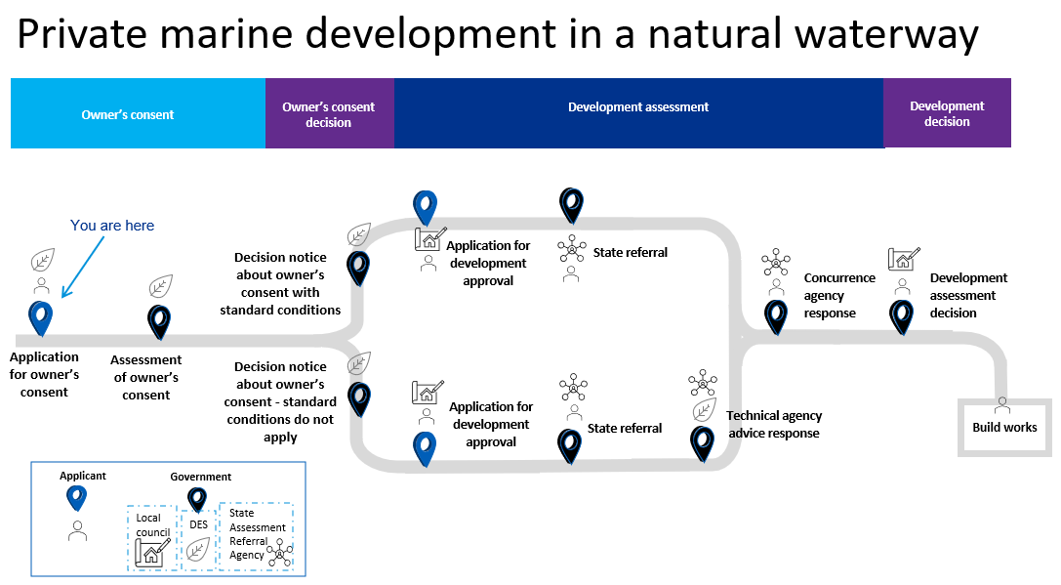
This form is also used where Noosa Shire Council requires a material change of use application for private marine development (private landing) over tidal water.
For more information about when owner’s consent is required for a development application, refer to the Queensland government website Owner’s consent for a development application.

Assessment timeframe
The department will endeavour to decide your application within 30 business days of receipt of a valid application. The department aims to review the application information within 10 business days of receipt and will advise you if your application does not provide all the information required. If the required information is not received within a further 10 business days, your application will be made invalid.

Privacy statement
The department is committed to protecting the privacy, accuracy and security of your personal information in accordance with the Information Privacy Act 2009. The department is collecting your personal information in accordance with section 51 of the Planning Act 2016 in order to process your application. The information will only be accessed by authorised employees within the department. Some of this information may be given to the Department of Resources or Maritime Safety Queensland (MSQ), for the purpose of the joint approval of owner’s consent. Your information will not be given to any other person or agency unless you have given us permission, or we are authorised or required by law. All information supplied on this form may be disclosed publicly in accordance with the Right to Information Act 2009 and Evidence Act 1977. For queries about privacy matters email: privacy@des.qld.gov.au or telephone: 13 QGOV (13 74 68).
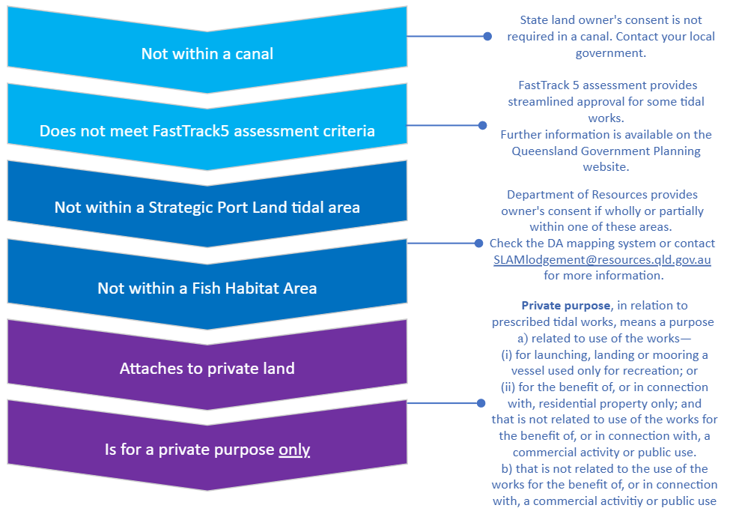
When to use this form?

- Applicant (Landowner(s)) details
NAME(s) OF landowner(s) as per the deed of title |  | Please indicate the type of ownership of the land  Private ownership ☐  Ownership held by trust ☐  Corporation or company ☐  Body corporate ☐
LANDOWNER(S) POSTAL ADDRESS |  |  | POSTCODE
TELEPHONE (BUSINESS HOURS) | MOBILE
EMAIL ADDRESS

- Details of entity acting on behalf of the applicant (if applicable)
NAME(s) OF entity(s) (you must provide evidence of authorisation to act on behalf of the LANDOWNER)

CONTACT PERSON

Entity’S POSTAL ADDRESS |  | POSTCODE
TELEPHONE (BUSINESS HOURS) | MOBILE
EMAIL ADDRESS

- Location of proposed works
STREET ADDRESS

LOT | PLAN
name of waterway in which works are proposed

LOCAL GOVERNMENT AREA

- Description of proposed works
NEW WORKS
Jetty ☐ | Pontoon ☐ |  |  | Boat ramp ☐ |  | Mooring pile ☐
Other type of marine access structure (please specify) ☐
ALTERATION TO Existing works
Demolition (please specify) ☐ |  |  | Modification or repair (please specify) ☐
- Low risk works checklist
Where all of the below low risk items are met, you may be eligible for a streamlined development assessment process for your tidal works application.
The works are a jetty or pontoon gangway with a maximum width of 3 metres, or a pontoon with a maximum width of 3.5 metres.
Refer to Appendix 2 - Allowable widths for private marine access structures.
The works do not require clearing or damage to native vegetation on the bank of the waterway (including mangroves).
The works do not require hardening or modification of the bank or bed of the waterway (with rock, concrete, gabions etc. for seawalls or erosion protection).
The works do not require dredging in tidal water.
The works do not adversely affect the use of the waterway by others (e.g. impeding navigable access at any time of the tide, or extending beyond one third of the width of the waterway between the high-water marks).
The works design will not block or divert the natural water flow along the waterway.
The works do not require a covenant on the land adjacent to the tidal water.
- Mandatory requirements checklist
All of the below requirements must be met to be granted owner’s consent for the use of State land.
The proposed work is solely for a marine access purpose.
Marine access purpose means a structure in tidal water used to facilitate vessel access for people between land and a navigable waterway. This includes jetties, pontoons and boat ramps but excludes decks and boardwalks (SDAP State Code 8).
The proposed work minimises the use of State coastal land.
Minimises the use of State coastal land is met where the plans show all of the following:
a. only one structure of its type is proposed.
Note: This means that there can be only one jetty or one pontoon (includes an abutment and fixed gangway), but not both. However, it is permitted to have a boat ramp in addition to a jetty or pontoon. One exception may be when the waterfront lot is common property under a Community Titles Scheme (CTS), in which case up to one vessel berth per waterfront residence may be supported.
b. size of the private marine development is the minimum size needed to achieve marine access for a single vessel:
- the deck of a jetty must not be wider than 3m or 3.5m for a pontoon (unless there is an engineering or specific use requirement for the extra width that has been accepted by DESI – see Appendix 3); and
- the length of the pontoon must be the minimum length to safely moor the required vessel and must not be longer than the vessel unless justified by a RPEQ.
c. the size of the proposed structure is not increased beyond the limits stated above to accommodate the berthing of more than one vessel (including vessels such as jet skis) or to allow for dry berthing of a vessel.
d. the structure is not to be roofed or otherwise covered.
e. redundant structures are removed from State coastal land.
Note: Additional vessels such as jet skis may be dry-berthed on a pontoon if it does not require a larger pontoon unit to accommodate this.
A Water Allocation Area Plan is attached showing the proposed work.
Refer to the guideline Preparing a water allocation area for tidal works in natural waterways (EPP/2016/2088), which is available on the Queensland government website at www.qld.gov.au using the publication number “EPP/2016/2088” as a search term.
Where the proposed work is partly or wholly within a marine park, a marine park permit is approved.
Follow the steps outlined in Appendix 1 to check if your proposed development is located wholly or partly within a marine park.
A Marine Park permit is required and the Marine Park permit number is:
N/A
Where the proposed works are in an area administered by the Gold Coast Waterways Authority early concurrence advice is given stating that the water allocation area is suitable for the intended structure.
Section 7 of the Gold Coast Waterways Authority Act 2012 details the areas administered by the Gold Coast Waterways Authority, they include the waters within the Gold Coast City local government area.
A copy of the early concurrence advice from the Gold Coast Waterways Authority is attached.
N/A
Where the proposed works will attach to an existing structure (such as a revetment wall) the existing structure must:
Hold the necessary approvals (please specify):
EXISTING STRUCTURE TYPE (e.g. JETTY, PONTOON, REVETMENT) | PERMIT NUMBER or OTHER RELEVANT EVIDENCE
Note: An application for owner’s consent may be invalid if details about existing tidal work structures are not provided. Please see Appendix 3 for more information on how to deal with existing unapproved structures.
If unapproved, be included with the development application for assessment.
- Other State referrals
In some instances, other State agencies are required to support the owner’s consent application. These are identified below and may extend the response time to your application.
The proposed work and the moored vessel will be within a navigation corridor and/or a high risk maritime development zone.
Navigation corridors and high risk maritime development zones are shown on the DA mapping system. Waterways in the Gold Coast local government area do not have a mapped navigation corridor or a high risk maritime development zone.
Joint assessment of owner’s consent is required with Maritime Safety Queensland (MSQ). The department will seek advice from MSQ and advise of any concerns.
The proposed work is located seaward of a quay line that is set for the waterway.
Joint assessment of owner’s consent is required with Maritime Safety Queensland (MSQ). The department will seek advice from MSQ and advise of any concerns.
- Other existing tidal works not attached to proposed work
Are there other existing approved works (not captured above against question 6 as those that attach to the proposed works)? | YES  Please list the approved tidal works and any other permit/reference number applicable or evidence of approvals:  - ______________________________  - ______________________________  - ______________________________ | NO → See Appendix 3 – Unapproved tidal works  Compliance action may be considered if efforts are not taken to include the unapproved works in the development application. Please discuss your intentions with the department.
UNSURE
Please advise approximate year the structure was built and include clear photos of the structure with this application.
Note: An application for owner’s consent may be invalid if details about existing tidal work structures are not provided above. Please see Appendix 3 for more information on how to deal with unapproved structures.
- Declaration
If you have not told the truth in this application you may be liable for prosecution under the relevant Acts or Regulations and any owner’s consent provided may be withdrawn.
- For a body corporate, trust or company I am lawfully authorised to make this application for the entity and that entity has agreed to this application being made.
- If I am not the adjoining landowner for the works I have provided a signed letter from the landowner, permitting me to lodge this application on their behalf.
- I declare that the information provided is true and correct to the best of my knowledge.
- I have prepared a water allocation area plan in accordance with the DESI guideline Preparing a water allocation area for tidal works in natural waterways (EPP/2016/2088).
- I understand that all information supplied on or with this application form may be disclosed publicly in accordance with the Right to Information Act 2009 and the Evidence Act 1977.

full name(s) of Applicant(S) (LANDOWNER(S)) / person acting on behalf of applicant
(*if MULTIPLE LANDOWNERS exist, ensure full names and signatures provided for ALL LANDOWNERS)

 | signature of Applicant(s) / person acting on behalf of applicant |  |  | DATE
Applicant checklist  IMPORTANT Please provide the following documents:  One copy of supporting information and drawings of the proposed work certified by a registered professional engineer of Queensland (RPEQ)  AND  A Water Allocation Area Plan  OR  For tidal water administered by the Gold Coast Waterways Authority (GCWA) - a copy of the early concurrence advice  AND  Marine Park permit (if required)  AND  A letter of consent from the landowner (if lodging on behalf of the landowner)  Note: The department will retain these copies for reference. |  | Please return your completed application form and supporting information to:  Permit and Licence Management  Department of Environment, Science and Innovation  GPO Box 2454  Brisbane QLD 4001  Enquiries: 13 QGOV (13 74 68)  Email: palm@des.qld.gov.au
.
Appendix 1 - Owner’s consent for proposed work that is partly or wholly within a marine park

A marine park permit is required for all work that is proposed to be located partly or wholly within a marine park. It is recommended that you establish whether or not a marine park permit is required prior to applying for owner’s consent to avoid applying unnecessarily. Follow the steps below to establish how to proceed with the owner’s consent application.

Step 1
Refer to the relevant marine park zoning plan to determine if the owner’s consent application area is within a State marine park and if so, the relevant zone.

The zoning plans for each marine park can be obtained from the following links:

Moreton Bay Marine Park
https://parks.des.qld.gov.au/__data/assets/pdf_file/0028/159931/map1-zoning.pdf
https://qldglobe.information.qld.gov.au/
Note. A digital layer containing the zoning and boundary for the Moreton Bay Marine Park is available on http://qldspatial.information.qld.gov.au/catalogue/custom/index.page - search for Moreton Bay Marine Park Zoning 2008.

Great Sandy Marine Park
https://parks.des.qld.gov.au/parks/great-sandy-marine/about
Note. A digital layer containing the zoning and boundary for the Great Sandy Marine Park is not currently available.

Great Barrier Reef Coast Marine Park
https://qldglobe.information.qld.gov.au/
http://www.gbrmpa.gov.au/zoning-permits-and-plans/zoning/zoning-maps
Note. A digital layer containing the zoning and boundary for the Great Barrier Reef Coast Marine Park is available on http://qldspatial.information.qld.gov.au/catalogue/custom/index.page - search for Great Barrier Reef Coast Marine Park Zoning

Step 2
Based on the marine park and the marine park zone that the tidal works are proposed within, identify the code in the table below and proceed to Step 3.
Marine park zone | Marine Park
 | Moreton Bay |  | Great Sandy | Great Barrier Reef Coast
 | Private jetty, pontoon or boat ramp | Private mooring pile structure | Private jetty, pontoon, boat ramp or mooring pile structure | Private jetty, pontoon, boat ramp or mooring pile structure
General use | 1 | 1 | 1 | 1
Habitat protection | 2 | 3 | 3 | 3
Estuarine conservation | N/A | N/A | N/A | 4
Conservation park | 2 | 4 | 4 | 4
Buffer | N/A | N/A | 4 | 4
Scientific research | N/A | N/A | N/A | 4
Marine National Park | 2 | 4 | 4 | 4
Preservation | N/A | N/A | N/A | 4
N/A – This marine park does not include this zone category.

Step 3
The action you will need to take for the code applicable to the proposed works is listed below. Refer to this and return to question 6 of the form.

1 – The installation of the structure will require a marine park permit. The marine park application form and further information can be found at https://www.qld.gov.au/environment/coasts-waterways/marine-parks/applying. Apply for a marine park permit and proceed with the owner’s consent application.

2 – It is recommended that you do not proceed with the owner’s consent application as it will be refused on the basis that a marine park permit cannot be granted. The Marine Park (Moreton Bay) Zoning Plan 2019 legislatively prohibits the construction of a private boat ramp, jetty or pontoon within all zones of the Moreton Bay Marine Park except for General Use zones. Should you require further information regarding the relevant zoning plan provisions email marineparksworks@des.qld.gov.au.

3 – It is recommended that you do not proceed with the owner’s consent application until confirming whether a marine park permit is likely to be granted. For information regarding the relevant zoning plan provisions email marineparksworks@des.qld.gov.au. Based on that advice, apply for a marine park permit and proceed with the owner’s consent application.

4 – Owner’s consent will not be granted until it can be demonstrated, through provision of a valid marine park permit that the proposed structure is compatible with the management of the marine park, as it may not meet the objects of the marine park zone at that location.

Further information about marine park permits and activities is available at https://www.qld.gov.au/environment/coasts-waterways/marine-parks/permits

Appendix 2 – Allowable widths for private marine access structures
JETTY
Maximum jetty width — 3 metres
Maximum pontoon width — 3.5 metres unless a suitably qualified engineer provides a statement that the pontoon cannot be designed to a maximum width of 3.5 metres for the intended purpose and the reasons why this criteria cannot be achieved. In most cases, this should be based off environmental factors present at the site. Note that the State will not accept a design exceeding 3.5m in width where the sole criteria is to accommodate anything other than the wet berthing of a single vessel.
See Appendix 3 for more information.
PONTOON
GANGWAY
Maximum gangway width — 3 metres
Maximum jetty width — 3 metres
JETTY / PONTOON
Prohibited structures (decks)
BOAT RAMP
Boat Ramp width
- with vehicle access—no less than 3.6 metres
- without vehicle access—no less than 3 metres
Appendix 3 – Important Information

Alternative requirements in certain circumstances
- Private marinas
In order to comply with the State code and the State Planning Policy, the department can only support one pontoon per lot, or per waterfront residence in the case of body corporate arrangements. Whilst a subject site exists as a single lot and/or has no building work commitment on the ground the department is unable to support owner’s consent for a private marina at this time.
Please note the following options in order to progress owner’s consent for a private marina in this scenario:
- Register an approved reconfiguration plan (Building Format Plan) with the Titles Office first and then proceed with applying for the private marina; or
- Provide evidence that a Material Change of Use and Reconfiguration of a Lot for the building works has been approved and the building work has substantially commenced on the multi-residential development, in which case you will need to demonstrate a critical need for having to construct the private marina at this early stage rather than after the reconfiguration has been registered.
Option 1 is the preferred approach because it has the lowest risk to the State.
If you wish to proceed with option 2 you need to provide evidence to the department that construction of the unit complex has substantially commenced. By this, it is expected that concrete slab/foundations have been installed at a minimum. The department would be satisfied that this would demonstrate a serious commitment to the building works and the development as a whole proceeding, which then justifies the size of the adjoining private marina. However, a case must be made to demonstrate why option 1 is not a viable option, i.e. what is the critical need for having the private marina approved at this early stage? Why can’t it wait until the lots are registered?
The above also applies in cases where, for example, it is proposed to subdivide 1 lot into 2 separate lots with a pontoon attaching to each. The residential development or the reconfiguration needs to occur first before the adjoining pontoons can be supported.
In terms of your own project confidence, it’s important to note that the department generally supports these types of proposals – the main issue is often around timing of the application. The department can informally work through any issues prior to lodging applications so when you are able to formally progress with owner’s consent it will be a faster process.

- Unapproved tidal works
Maintenance work is only permitted on tidal works that are lawful. Landowner’s are advised to seek approval for any unlawful tidal works attaching to the freehold lot to avoid compliance action. If private marine development is proposed to attach to an existing structure (e.g. revetment) the department must be satisfied the existing structure is lawful before proceeding with owner’s consent.
If the structures do not attach then the issue of the unapproved structure is a separate matter to the proposed structure and there are two options moving forward:
- The landowner needs to demonstrate that the existing structure is lawful. This can be done by requesting a search of historic records:
  - Issued prior to 18 November 2005 – at the following link: https://www.qld.gov.au/environment/coasts-waterways/plans/development/tidal-works/approvals-search
The Queensland Globe search is free. Fees apply if requesting a search or copies of approvals
  - Issued on or after 18 November 2005 – Council.
- If the above does not produce any results and the landowner cannot provide any evidence that the existing structure is lawful, the next steps are:
  - Obtain retrospective approval for the existing structure – provide detailed drawings and submit it to Department of Resources for owner’s consent along with the proposal for private marine development.
  - If you do not wish to have the existing structure assessed concurrently with the private marine development, the department can progress the private marine development application separately, however the existing structure will be reported to the relevant compliance team as an unlawful structure requiring investigation. Penalties apply.

- Uncertain property boundaries – survey required
It is common for lots adjoining a waterway to have an ambulatory boundary. This means the tidal boundary may move over time and therefore the current location of the boundary may not be accurately reflected on the existing survey plan for the lot. If there is doubt as to the legal status of the current boundary an identification survey is required. The identification survey must be prepared by a registered consulting surveyor and show the current legal location of your property boundary in order for the department to progress the application for owner’s consent.
Your application will be closed. Once an identification survey has been acquired that clearly shows the current legal boundary of the lot please re-lodge your application for owner’s consent to the department.

- Pontoons wider than 3.5 metres
Private infrastructure on State tidal land is only supported if it provides a marine access purpose and the size of the structure is the minimum size required to safely moor a single vessel. Please refer to Appendix 2 for more information on allowable widths for private marine access structures. If there is a justified need for a pontoon wider than 3.5 metres please note the following:
- Landowners of a property have no right or entitlement to construct any marine access structure (jetty, pontoon, boat ramp etc) on State tidal land without first obtaining consent from the State.
- The use of State land for private purposes is to be minimised as far as possible to preserve the public use of State land.
- The State has set reasonable limits to the size of private marine access structures on State tidal land (i.e. 3.5m wide).
RPEQ report
A case may be made for an increase in these limits but to support this the State will require a report from a suitably qualified and experienced RPEQ that:
- Explains what special case exists to require these limits to be extended;
- Explains why there are no possible design solutions that can meet the State mandated limits; and
- Describes the minimum design needed to achieve the desired requirement – noting that the justification for a 4m wide pontoon must not be based on the need to dry berth a vessel; the wider pontoon size must be required due to environmental factors present at the site only.
Please note
- The State reserves the right to have such a case independently reviewed.
- Despite the above, the State may decide not to allow a structure beyond the set limits for any reason related to protection of the coastal environment and preservation of public use of State tidal land.
- At all times the State solely determines what is a reasonable use of State land for private marine access purposes.

- Fish Habitat Areas (FHA)
It is advised to consult the declared FHA plans online to delineate the exact boundary for the FHA as they are quite specific. Note also that no development is permitted within a FHA A, and only a single marine access structure is permitted within a FHA B, with some limited exceptions. To further clarify FHA B, if you have a boat ramp you will not be permitted to have anything else.
FHA plans can be found at the following link - https://parks.des.qld.gov.au/management/managed-areas/fha/area-plans.

Owner’s consent is evidence that the owner of the land that is the subject of a development application has consented to the making of the application. The department can provide owner’s consent for private marine development on State owned land under tidal water on behalf of the Department of Resources.
The Department of Environment, Science and Innovation is the custodian of historical tidal works approvals issued prior to 18 November 2005. To search for a historical approval go to Searches for Historical Tidal Works Approvals at https://www.qld.gov.au/environment/coasts-waterways/plans/development/tidal-works/approvals-search. Local government have been issuing approvals for prescribed tidal works post 18 November 2005 and will be able to assist with searches for works approved after this date. Details of these fees are in the DESI Information sheet: Fees and royalties payable under the Coastal Protection and Management Act 1995 (available at www.qld.gov.au using the publication number ESR/2015/1854 as a search term).
This guideline is available on the Queensland government website at www.qld.gov.au using the publication number “EPP/2016/2088” as a search term.
Unless a more stringent requirement is set in a Planning Scheme.

