Application form
Environmental Protection Act 1994

Application to amalgamate 2 or more environmental authorities into an amalgamated corporate authority
This document is the approved form that is to be used by the holder of 2 or more environmental authorities to apply to the administering authority for an amalgamated corporate authority under sections 243 to 246 of the Environmental Protection Act 1994 (EP Act). This is also the approved form to change the anniversary day for an amalgamated corporate authority under section 316L of the EP Act.
Only use this form if you hold environmental authorities at multiple sites and would like to amalgamate them into the 1 amalgamated environmental authority.
Once amalgamated, there will only be 1 environmental authority with a combined set of conditions. The highest annual fee at each site must still be paid annually.
If you would like to have a pre-lodgement meeting:
- For prescribed ERAs 2, 3 or 4—contact the Department of Agriculture and Fisheries by email at livestockregulator@daf.qld.gov.au.
- For any other ERA—please fill out and lodge the form Application for pre-lodgement services (ESR/2015/1664) prior to lodging this application form.
Checklist for making an application for an amalgamated corporate authority
You must complete this checklist before you continue with the application form.
Depending on the results of your answers to the checklist questions, you may not be able to use this application form.
Checklist questions |  | Guidance
Is the administering authority the same for all of the environmental authorities you want to amalgamate? | ☐ YES  ☐ NO | If no, you cannot make this application. An application can only be made if all the environmental authorities are administered by the department.  For example, if 2 environmental authorities have been approved by the department and a third environmental authority has been approved by a local council, then only the 2 environmental authorities approved by the department can be amalgamated using this application form. If a number of environmental authorities are administered by a different administering authority e.g. a local council, then an application may be made to that administering authority using their application form. Environmental authorities issued by different local councils cannot be amalgamated.
Are any of the environmental authorities to be amalgamated held jointly by different entities? | ☐ YES  ☐ NO  ☐ N/A | If yes, you cannot make this application. An application can only be made if all the environmental authorities are held by the same joint entities.  Example 1: A parent company could not amalgamate the environmental authorities owned by its subsidiary companies, since that would create confusion about which person is responsible for compliance with the conditions of the amalgamated environmental authority  Example 2: A common holder of the environmental authorities could not amalgamate if there are different joint holders on some or all of the environmental authorities. Again, this would create confusion about which person is responsible for compliance with the conditions of the amalgamated environmental authority.
Definitions of terms used in this form
Where there is inconsistency between the definition of terms here and the terms used in the EP Act, the terms in the EP Act apply.
Environmentally relevant activity (ERA) | A resource activity or a prescribed ERA
Prescribed ERA | An ERA that is not a resource activity and is prescribed under section 19 of the EP Act.
Resource activity | An activity that is any of the following:  - a geothermal activity  - a greenhouse gas (GHG) storage activity  - a mining activity  - a petroleum activity.

GUIDE | Application details
If you require assistance in answering any part of this form, or have any questions about your application please contact the relevant department. Contact details are at the end of this form  The environmental authority number and details may be found on the existing environmental authority or quoted in other correspondence received from the administering authority.  If more space is required for any responses, please attach additional information as a separate page.  If there is an agent acting on behalf of the environmental authority holder, provide details in this section. An agent could be a consultant or a contact for the environmental authority holder.  As statutory documents need to be sent to all applicants, this section is to also be used when there are multiple environmental authority holders to nominate an address for statutory documentation to be sent ‘care of’ to. | Environmental authority numbers to be amalgamated  ENVIRONMENTAL AUTHORITY NUMBER ENVIRONMENTAL AUTHORITY HOLDER NAME(S)  Insert reference number. Insert name.  Insert reference number. Insert name.  Insert reference number. Insert name.  Agent details/address for service  The address supplied here will also be used as a service address for sending statutory documents. If this section is left blank, statutory documents will be sent to the address previously supplied for the holder or principal applicant for the continuing environmental authority.  INDIVIDUAL OR BUSINESS NAME (INCLUDE TRADING NAME IF RELEVANT)  Insert name.  RESIDENTIAL ADDRESS OR REGISTERED BUSINESS ADDRESS (NOT A POST OFFICE BOX ADDRESS)  Insert address.  POSTAL ADDRESS (IF DIFFERENT FROM ABOVE)  Insert address.  CONTACT PERSON  Insert name.  PHONE Insert phone no. FACSIMILE Insert fax no.  EMAIL  Insert email.

Does this application include the amalgamation of an environmental authority for a petroleum activity authorised under a petroleum lease where a plan of operations is in effect?
☐ → Yes—you must submit an amended version of the plan of operations which covers all the applicable sites requested for amalgamation.
☐ → No

Does this application involve a mining activity authorised under a mining lease for which a PRC plan relates?
☐ → Yes—you must submit a proposed amalgamated PRC plan for the activities.
☐ → No

Do any of the following apply?
Have you previously lodged, and are now awaiting a decision on an application to amend any 1 of the environmental authorities that are the subject of this application?
☐ → Yes— include details of the application to amend an environmental authority e.g. relevant ERA, location and date the amendment application was lodged.
☐ → No
Do you intend to concurrently lodge a separate application to amend any 1 of the environmental authorities that are the subject of this application?
☐ → Yes— include details of the application to amend an environmental authority e.g. relevant ERA and location.
☐ → No
DETAILS
Insert.

The administering authority may use the information (as described in Q.5) provided to create an amalgamated environmental authority with streamlined conditions for two or more project sites. However, this will be at the discretion of the administering authority and agreed to by the applicant. | Do you wish to amend the condition(s) of the environmental authority?  One of the benefits of an amalgamated authority is that any duplicate or contradicting conditions across sites can be amended to allow a more streamlined set of conditions across all project sites. The department will confirm your agreement with any final variations to the conditions.  Note once amalgamated, each existing environmental authority will become a project site on the amalgamated environmental authority.  ☐ No  ☐ Yes – provide details below.  Provide details of: a) section(s) or condition(s) numbers requiring changes; b) the recommended changes; c) brief justification.  Insert.  ☐ → I HAVE ATTACHED ADDITIONAL DETAILS FOR THIS SECTION
The nominated anniversary day will become the anniversary day for the amalgamated corporate authority. This will give a single date for the reporting and payment of annual fees.  The fee for changing the anniversary day will apply (see question 7 for more fee information). | Nominated anniversary day (day and month only).  NOMINATED ANNIVERSARY DAY  Insert.
The first step towards payment is to calculate the fees payable. Information on these fees can be located in the information sheets ‘Fees for permits for environmentally relevant activities (ERAs)’ (publication number ESR/2015/1721) and ‘Summary of annual fees for environmentally relevant activities (ERAs)’ (publication number ESR/2015/1746), available at www.qld.gov.au using the publication number as a search term.  The fee payable for an anniversary day changeover must be worked out using the formula in section 176 of the Environmental Protection Regulation 2019. A summary of the formula and an example has been provided in Attachment 1.  To pay by credit card you will need to provide contact details so you can be contacted for your credit card payment to be made over the phone. This function is only available for payments to Department of Agriculture and Fisheries. | Payment of fees  The amalgamated corporate authority application fee is: $ Insert amount.  The anniversary day changeover fee is: $ Insert amount.  Total fee is the sum of the above: $ Insert amount.  You may pay your application and anniversary day changeover fee via cheque, money order or credit card.  Select the payment method below:  For fees payable to the Department of Environment, Science and Innovation:  Preferred  ☐ Apply using Online Services – submit the application online and pay by credit card  https://business/qld.gov.au/running-business/environment/online-services.  Alternatively  ☐ Email the completed application with a request to pay the application fee by Bpoint. Please do not email your credit card details – we will send you a link to pay securely by credit card via BPoint.  For fees payable to the Department of Agriculture and Fisheries:  ☐ Payment by cheque or money order made payable to the Department of Agriculture and Fisheries (attached).  ☐ Please contact me (the applicant) for credit card payment, (Department of Agriculture and Fisheries only):  Phone number: Insert phone no.
Where there is more than 1 holder of the environmental authority, this declaration is to be signed by all holders, unless there is an agreement between all holders that 1 can sign on behalf of the other.  Note: If only 1 holder is signing this application form, they are committing all holders to the content of the application and the declaration.  Where the environmental authority holder is a company, this form must be signed by an authorised person for that company.  Privacy statement  The Department of Environment, Science and Innovation (DESI) and the Department of Agriculture and Fisheries (DAF) are committed to protecting the privacy, accuracy and security of your personal information in accordance with the Information Privacy Act 2009. The departments are collecting your personal information in accordance with section 243 to 246 of the Environmental Protection Act 1994 in order to process your application. The information will only be accessed by authorised employees within the department. Some of this information may be given to the Department of Resources, for the purpose of the joint regulation of mining activities. Some of this information may be provided to Queensland Treasury, the Scheme Manager under the Mineral and Energy Resources (Financial Provisioning) Act 2018 (MERFP Act), or any advisors to the Scheme Manager to enable the Scheme Manager to carry out the Scheme Manager’s functions under the MERFP Act. Some of this information may be given to the Rehabilitation Commissioner in accordance with the Environmental Protection Act 1994 if accessing the information is necessary or convenient to be done in the performance of the Commissioner’s functions. Your information will not be given to any other person or agency unless you have given us permission or we are authorised or required by law. All information supplied on this form may be disclosed publicly in accordance with the Right to Information Act 2009 and Evidence Act 1977. For queries about privacy matters email: privacy@des.qld.gov.au or telephone: 13 QGOV (13 74 68). | Declaration  If you have not told the truth in this application you may be prosecuted.  Where an agreement is in place between all holders of the environmental authority, that one holder can sign on behalf of the other joint holders, please tick the below checkbox.  ☐ I have the authority to sign this form on behalf of all the joint holders of the environmental authority.  I declare that:  - I am the holder of the environmental authorities or an authorised signatory for the environmental authorities described in question 1 and commit the person to all matters relevant to this application.  - The information provided is true and correct to the best of my knowledge.  - I understand that it is an offence under section 480 of the Environmental Protection Act 1994 to give to the administering authority or an authorised person a document containing information that I know is false or misleading in a material particular.  - I understand that under section 480A of the Environmental Protection Act 1994 that, if I am required to give a document to the administrating authority or an authorised person, it is an offence to give a document that contains incomplete information in a material particular.  - I understand that I am responsible for managing the environmental impacts of the activities covered by this application and that approval of this application is not an endorsement by the administering authority of the effectiveness of management practices proposed or implemented.  - I understand that all information supplied on or with this application form may be disclosed publicly in accordance with the Right to Information Act 2009 and the Evidence Act 1977.  - I understand that an incomplete application (including applications that do not include the correct fee) may be invalid. Invalid applications will be returned without processing and will only be processed if resubmitted with all invalidating issues addressed.  APPLICANT’S NAME  Insert name.  APPLICANT’S SIGNATURE  POSITION OF SIGNATORY Insert position. DATE Click here to enter a date.  JOINT HOLDER’S NAME (IF APPLICABLE) Insert name. JOINT HOLDER’S SIGNATURE (IF APPLICABLE)  JOINT HOLDER’S NAME (IF APPLICABLE) Insert name. JOINT HOLDER’S SIGNATURE (IF APPLICABLE)
Applicant checklist
☐ Application form for an amalgamated corporate authority signed and completed.
☐ Question 1: Additional details have been attached describing all environmental authorities to be amalgamated (if required).
☐ Question 2: An updated plan of operations has been attached (if required).
☐ Question 3: A proposed amalgamated PRC plan has been attached (if required).
☐ Question 5: Conditions requiring amending on the amalgamated environmental authority have been identified and attached.
☐ Question 6: New anniversary date nominated (if applicable).
☐ Fees enclosed (DESI and DAF) or contact details provided for credit card payment (available only with DAF).
Further information  The latest version of this publication and other publications referenced in this document can be found at www.qld.gov.au using the relevant publication number (ESR/2015/1734 for this document) as a search term. | Please submit your completed application kit to:  For ERA 2, ERA 3 or ERA 4  Post: Senior Environmental Scientist Animal Industries Department of Agriculture and Fisheries PO Box 102 TOOWOOMBA QLD 4350 Enquiries: Phone: (07)13 25 23 Fax: (07) 4529 9233 Email: livestockregulator@daf.qld.gov.au  For all other ERAs  Post: Department of Environment, Science and Innovation GPO Box 2454 BRISBANE QLD 4001 Enquiries: Permit and Licence Management Phone: 13 QGOV (13 74 68) Email: palm@des.qld.gov.au

Attachment 1
Calculating the anniversary changeover application fee
The fee for an anniversary day changeover is calculated using the following formula from section 176 of the Environmental Protection Regulation 2019 (EP Reg):
F = $380.20 | + (sum of | (A x N) | for each site)
 |  | 365
Where:
F = is the fee for the anniversary changeover
A = is the annual fee for the environmental authority.
N = is the number of days in the interim year (the period starting on the old anniversary day for the environmental authority and ending on the new anniversary day in the following year after the proposed change).
$380.20 is the application fee component to change the anniversary day.

Example anniversary day changeover calculation
A business is proposing to amalgamate 2 environmental authorities (EAs) into the 1 amalgamated corporate authority. The application to amalgamate the 2 EAs and align the anniversary days is lodged on 31 March. Within the application, the applicant has requested to have the anniversary day aligned to 30 June. Refer to Table 1 for a summary of the 2 EAs held.
Table 1: Description of environmental authority sites and annual fees
ERA activity | Annual fee | Current anniversary day | Proposed anniversary day
Environmental authority 1—project site 1
Site A
ERA 8(2) | $15,498.90 | 1 February | 30 June
ERA 64(4)(b) | $13,675.50 | 1 February | 30 June
Site B
ERA 64(2)(b) | $3,950.70 | 1 February | 30 June
Environmental authority 2—project site 2
Site C
ERA 63(2) | $755 | 1 August | 30 June

Environmental authority 1
N = 149 days (see Figure 1)
A = $15,498.90
Environmental authority 2
N = 333 days (see Figure 1)
A = $755.00
Total fee calculation
The fee payable for aligning the anniversary day is:
F= | $380.20 | + | (project site 1 calculation) | + | (project site 2 calculation)
F= | $380.20 | + | ($15,498.90 x 149 ÷ 365) | + | ($755 x 333 ÷ 365)
F= | $380.20 | + | $6,326.95 | + | $688.81
F= | $7,395.96

Figure 1: Calculating the interim year
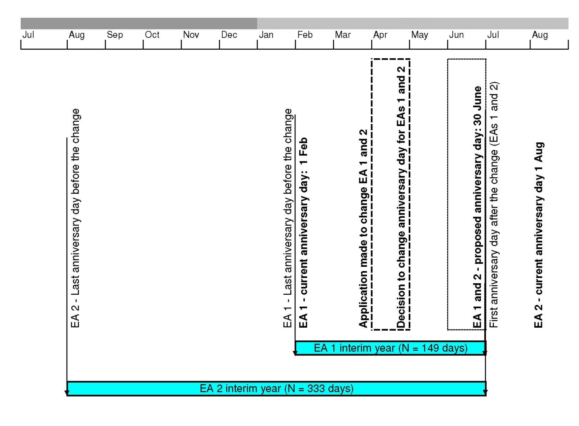

Refer to Attachment 1 for details on how to calculate this fee.

